ADP GlobalView®

Master Data Requirements: Australia

RMIT Australia Pty Ltd

Commercial in Confidence

|  |  |
| --- | --- |
| **Author** | Kathy Fraser |
| **Document Reference** | GV00009336 |
| **Date** | 28/11/2019 |
| **Version** | 1.4 |

##### Copyright and Confidentiality

Copyright © 2015, 2016 ADP, LLC. ADP Proprietary and Confidential - All Rights Reserved. For Internal Use Only. These materials may not be reproduced in any format without the express written permission of ADP, LLC. This document must be kept strictly confidential at all times. It must not be disclosed to any person without the prior written consent of ADP, LLC.

ADP provides this publication "as is" without warranty of any kind, either express or implied, including, but not limited to, the implied warranties of merchantability or fitness for a particular purpose. ADP is not responsible for any technical inaccuracies or typographical errors which may be contained in this publication. Changes are periodically made to the information herein, and such changes will be incorporated in new editions of this publication. ADP may make improvements and/or changes in the product and/or the programs described in this publication at any time without notice.

The ADP® logo and ADP® letters are registered trademarks of ADP, LLC. GlobalView® is a registered trademark of ADP, LLC. iLearn@ADP® is a registered trademark of ADP, LLC. In the Business of Your Success(SM) is a service mark of ADP, LLC.

**Third-Party Trademarks**

Adobe® is a registered trademark and Acrobat(TM) is a trademark of Adobe Systems Incorporated.

Microsoft®, Windows®, Internet Explorer®, Word®, and Excel® are registered trademarks of Microsoft Corporation.

SAP® and SAP® R/3® are registered trademarks of SAP AG in Germany and in several other countries.

All other trademarks and service marks are the property of their respective owners.

##### Release Notice

This document applies to the ECC6 SAP R/3 version of the GlobalView® product solution. It is valid for ECC6-upgraded projects as well as new implementations done on the ECC6 template. It includes documentation of template enhancements from January 2011 and forward. Check the Document Attributes panel for reference to the ECC5 version.

##### Authorizations and Amendments History

| Version | Authored | Release Date | CRM Ticket | Approved |
| --- | --- | --- | --- | --- |
| 1.0 | Kathy Fraser | 27/09/2019 |  |  |
| 1.1 | Kathy Fraser | 09/10/2019 |  |  |
| 1.2 | Kathy Fraser | 21/10/2019 |  |  |
| 1.3 | Kathy Fraser | 07/11/2019 |  |  |
| 1.4 | Kathy Fraser | 28/11/2019 |  |  |
|  |  |  |  |  |
|  |  |  |  |  |

##### Table of Contents

1. Master Data – Introduction 5

1.1 Initial Data Load (IDL) 5

1.2 ADP Spreadsheet Loader 5

1.3 Time Constraint Rules 6

1.4 Relationship between Infotypes and Records 6

1.5 Data Upload Sequence 7

2. RMIT AU Data Conversion 8

2.1 Initial Data Conversion 8

2.2 YTD Data 10

2.3 Pre Go-Live Payments 11

2.4 Pre Go-Live Terminated Employees 11

2.5 Data Mapping 12

3. Infotype Overview – General 13

Infotype 0000 – Actions 13

Infotype 0001 – Organisational Assignment 14

Infotype 0002 – Personal Data 15

Infotype 0006 – Addresses 16

Infotype 0007 – Planned Working Time 17

Infotype 0008 – Basic Pay 18

Infotype 0009 – Bank Details 19

Infotype 0011 – External Transfers 20

Infotype 0014 – Recurring Allowances and Deductions 21

Infotype 0015 – Additional Payments 22

Infotype 0016 – Contract Details 23

Infotype 0027 – Cost Distribution 24

Infotype 0041 – Date Specifications 25

Infotype 0045 – Loans 26

Infotype 0078 – Loan Payments 27

Infotype 0105 – Communications 28

Infotype 0709 – Global ID 29

Infotype 2001 – Absences 30

Infotype 2003 – Substitutions 31

Infotype 2006 – Absence Quotas 32

Infotype 2010 – Employee Remuneration Information 33

Infotype 2012 – Time Transfer Specifications 34

Infotype 2013 – Quota Corrections 35

4. Infotype Overview – Country Specific (AU) 36

Infotype 0188 – Tax Australia 36

Infotype 0220 – Superannuation Australia 37

Infotype 0227 – Tax File Number 38

Infotype 0817 – Withholding Tax Variation 39

5. Appendix 40

5.1 ADP Reference Documents 40

# Master Data – Introduction

GlobalView® categorises data types according to the following table –

| **Data Type** | **Data Set** | **Description** | **Meaning** |
| --- | --- | --- | --- |
| Infotype | P0000–P0999 | Payroll Infotypes | Infotypes required to process payroll  e.g. P0002 Personal Data, P0006 Addresses etc. |
| Infotype | P2000–P2020 | Basic Time Infotypes | Infotypes containing time events e.g. P2001 Absences, 2002 Attendances, 2003 Substitutions etc. |
| Other Master Data | BNKMD | Bank Keys | Bank-State-Branch numbers, bank names |
| Other Master Data | CCRMD | Cost Centres | Organisational Cost Centre codes |
| Other Master Data | WBSEL | WBS Element | WBS Element |
| Other Master Data | HROBJ | HR Objects | Position descriptions |
| New Hire | NHIRE | New Hire | Composite spreadsheet containing all the values required to create an Employee ID in the system |

### Initial Data Load (IDL)

Initial Data Load PECI Full Snapshot functionality focuses on data that can be extracted and transformed via PECI from the Workday system for clients implementing GlobalView payroll. It will create the HRMD Data Conversion files from Workday using the already tested PECI integration. Please note this must be used for both Parallel and Go-Live data conversion activities to ensure accuracy.

### ADP Spreadsheet Loader

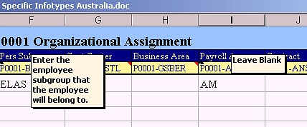ADP Spreadsheet Loader (SSL) is used to format data for loading into GlobalView®.

This document assumes familiarity with ADP Spreadsheet Loader (SSL) – refer to Appendix for detailed SSL End User Guides.

When completing the Upload Spreadsheets, check the notes in the column headings which will assist with entering the information correctly. Do not provide data where the note says leave blank. Red-lined cells indicate mandatory fields which must contain an entry.

SSL can be used for Master Data infotypes, Other Master Data, and transactional data.

Any of the Infotypes and Other Master Data types required may be selected for inclusion in an ADP SSL Workbook. Each data type is contained in a single worksheet as shown in the tabs at the bottom of the workbook –



### Time Constraint Rules

To maintain data integrity and prevent duplication of records every Infotype belongs to a Time Constraint class, which will determine whether a record must exist in the system at all times, whether multiple instances of the record can exist, and so on.

The following table provides a summary of Time Constraints –

| **Time Constraint** | **Rule** | **Includes** | **Examples** |
| --- | --- | --- | --- |
| 1 | Record must exist with no gaps, no overlaps | P0002 (Name) | Employee must always have a name record and can only have one name record |
| 2 | Record may include gaps but no overlaps | P2001 (Absence) | Employee does not have to be on leave but if on leave cannot be on more than one kind |
| 3 | Record may include gaps, and may overlap | P0009 (Bank Account) | Employee can have a number of secondary bank accounts and they may co-exist |

Refer to SSL End User Guides in the Appendix for detailed explanation.

### Relationship between Infotypes and Records

Infotypes are screens which gather data fields into logical groups. Records are created and maintained by the entry of data into Infotype screens. However records are different to infotypes.

A record is created when a start date is entered in an Infotype, either directly or via SSL.

This record has a beginning date of 02.02.2005 and continues indefinitely –



When a new record is created, say in the event of a name change, the End Date of the existing record is changed to the day before the new record’s Start Date. In other words the record is ‘delimited’ (if Time Constraint 1) –



Then the current record will start from the new date and continue indefinitely –



In overview, the records will look like this –

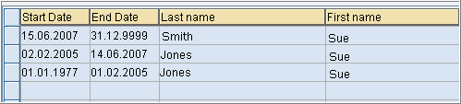

### Data Upload Sequence

During GlobalView® implementation, the sequence in which Infotypes and Other Master data types are uploaded is important. This is because certain values must be present in the system in order for records to be created.

**Upload Guidelines –**

* Cost Centre master data (CCRMD) must exist in the system prior to employee’s Organisational Assignment (P0001) being created if Cost Centre is to be assigned to an employee
* Bank Key master data (BNKMD) must be loaded before account information can be associated with an employee in Bank Detail (P0009)
* Creation of an Employee ID always requires a minimum of Infotypes 0000 (Actions), 0001 (Org. Assignment), 0002 (Personal Data), and 0041 (Date Specifications). The NHIRE worksheet is used to create new Employee IDs, as it contains all of these required entries
* Different countries have different Master Data requirements – while the general guidelines are the same, the particulars for each country may vary.

# RMIT AU Data Conversion

### Initial Data Conversion

For RMIT Australia Pty Ltd, it is expected that all initial data conversion will be performed by Initial Data Load (IDL) from WorkDay (WD). Additional master data and transactional data will be expected via SSL uploads (refer to Appendix for SSL templates). Any changes following Go-Live will then be managed by a combination of integration from WD HR system and SSL uploads.

The expected load sequence should be as per below –

| **Data Seq.** | **Object / Infotype** | **Description** | **Method** | **Note** |
| --- | --- | --- | --- | --- |
| 1 | BNKMD | Bank Master Data | SSL | Bank Keys |
| 1 | WBSEL | WBS Elements | SSL | WBS Elements |
| 1 | T5QSC | Superchoice Funds | Text |  |
| 2 | CCRMD | Cost Centre Master Data | IDL* | Cost Centres |
| 2 | HROBJ | Position Master Data | IDL* | Positions |
| 2 | NHIRE | NHIRE Employee Hire | IDL* | Employee Hire – includes P0000 Actions, P0001 Org Assignment, P0002 Personal Details, P0041 Date Specifications, P0709 Global ID (automatically loaded) |
| 2 | P0007 | Planned Working Time Infotype | IDL* | Work schedule details |
| 2 | P0008 | Basic Pay Infotype | IDL* | Salary details |
| 2 | P0105 | Communications Infotype | IDL* | Email, user ID |
| 2 | P0006 | Address Infotype | IDL* | Address details |
| 2 | P0009 | Bank Details Infotype | IDL* | Bank details |
| 2 | P0027 | Cost Distribution Infotype | IDL* | Cost distribution overrides |
| 2 | P0227 | TFN Infotype | IDL* | TFN details |
| 2 | P0014 | Recurring Payments/Deductions | IDL* | Recurring allowance details |
| *SSL template “NewHire” will be required for employees that are not being loaded through WD (for example employees who work in a second RMIT entity). In this case, please use WD ID followed by # to indicate that the employees are the same. If there is no WD ID, please assign a dunny ID outside the WD employee number range. | | | | |
| 3 | P2006 | Absence Quota | SSL | Absence quota shell |
| 3 | P0016 | Contract Elements | SSL | Contract details |
| 3 | P0188 | Tax Australia Infotype | SSL | Tax details |
| 3 | P0220 | Superannuation Infotype | SSL | Superannuation details |
| 3 | P0817 | Income Withholding Variation | SSL | Tax details |
| 4 | RPUTRBK0 | Update Control Record | - | Time retro accounting dates updated to reflect go-live date |
| 4 | RPTIME00 | Run Time Evaluation (1 day) | - | Create absence quota records to 31.12.9999 |
| 5 | P2013 | Quota Corrections | SSL | Leave balances (AL, LSL, PL, TIL, Purchased Lve, VE Teaching Leave) |
| 6 | RPTIME00 | Run Time Evaluation (1st Period) | - | Update quotas with leave balances |
| 7 | T558D&B | Payroll Account Transfer | PTD/ YTD  SSL | YTD payroll data for tax and average calculations |
| 8 | RPCALCQ0 | Run YTD Payroll | - | Create YTD payroll results |
| 9 | P0011 | External Transfers | SSL | Garnishee details |
| 9 | P0045 | Loans | SSL | Loan record |
| 9 | P0078 | Loan Payments | SSL | Outstanding balance for loan record |
| 9 | P0014 | Recurring Payments/Deductions | SSL | Recurring allowance/deduction details (not in WD) |
| 10 | RPUTRBK0 | Update Control Record | - | Time & Payroll retro accounting dates updated to reflect go-live date |
| **GV Go-Live** | | | | |
| 11 | Payment Adjustment Data | Payment adjustment data for 1st week of timesheet data that cannot be sent via WD | SSL | Employee data loaded into IT0015 (Additional Payments), IT2010 (Employee Rem. Info |
| 11 | WD Transaction Data (PECI) |  | WD | Employee data loaded into IT0015 (Additional Payments) |
| 11 | WD G2 |  | WD | IT2002 (Attendances) IT2010 (Employee Rem. Info), IT2001 (Absences), IT2003 (Substitutions) |
|  |  |  |  |  |
| **Parallel Transactional Data** | | | | |
| 8 | P0015 | Additional Payments | SSL | For parallel testing only |
| 8 | P0416 | Quota compensation | SSL | For parallel testing only |
| 8 | P2010 | Employee Remuneration Info | SSL | For parallel testing only |
| 8 | P2002 | Attendances | SSL | For parallel testing only |
| 8 | P2001 | Absence Data | SSL | For parallel testing only |
| 8 | P2003 | Substitution Data | SSL | For parallel testing only |

** Please note: Assumption is that master data changes (for example changes to basic pay) that are required for parallel run 2 will flow through PECI from WD. If this is incorrect, then we will need SSL for master data changes

### YTD Data

For RMIT Australia Pty Ltd, the only historical payment data to be migrated will be data required to support payroll calculations. The below table outlines such data sets –

| **Data Set** | **Purpose** | **Method** | **Data Conversion Requirement** |
| --- | --- | --- | --- |
| KM Allowance | To ensure correct calculation of taxable and non-taxable KM claims post Go-Live | PTD/YTD template | WT 93MK uploaded to T558B&D –  This should contain the total no of KMs claimed in the financial year up to the last pay period prior to go-live.  Can be loaded as 1 value into the pay period prior to go-live |
| Marginal Tax | To ensure correct calculation of marginally taxed payments | PTD/YTD template | WTs /201 & 9J71 uploaded to T558B&D.  This should contain the average taxable earnings for each historical pay period in the prior pay periods in the financial year up to the last pay period prior to go-live. This should exclude pre-tax earnings. |
| Service Fraction History | To enable calculation of paid parental leave | PTD/YTD template | WT 9PLC uploaded to T558B&D.  RMIT University only, 3 years  Service Fraction % value for each pay period from 3 years before Go live (max 78 periods) |
| Long Service Leave Total Hours and Total Gross | To enable calculation of LSL average calculation for casual employees | PTD/YTD template | For LSL average calculation we will need the values for each pay period from 5 years before Go live (130 periods i.e. if we go live May 2020, we would need every pay period from April 2015 – April 2020), and then just one average value for the period between Hire date – 5 years before go-live (i.e. Hire date – March 2015). |
| **OPTIONAL**  Eligible Termination Payments - Other Taxable payments | To ensure correct calculations of Whole of Income Cap for any ETP payments made on termination in the financial year | PTD/YTD template | WT I801 uploaded to T558B&D.  This should contain the other Taxable payments that have been paid in the financial year up to the last pay period prior to go-live that need to be included when calculating the WIC cap.  NOTE: this is only required when an ETP is being paid within the financial year, so can be loaded as needed during BAU. |
| Long Service Leave termination tax | To enable correct tax of Long Service Leave payouts on termination | IT2013 SSL | Leave balances to be migrated to different quota buckets based on when the accrual/entitlement was accrued –   1. 70 – Long Service Leave’ – accrual and entitlement post 17 August 1993 2. 71 – Long Service Leave 78-93’ – entitlement between 17 August 1978 and 17 August 1993 3. 72 – Long Service Leave Pre 78’ – entitlement pre 17 August 1978 |
| Overpayments | To enable recovery of any existing overpayments post Go-Live | IT0045 SSL | Following final payroll run, outstanding loan balance to be migrated to Infotype 0078 – Loan Payment using loan payment type 0300 Loan Balance Transfer , for loan type Z100 Overpayment (loan repayment schedule details loaded into Infotype 0045) |
| MYKI Balances | To enable recovery of any existing MYKI post Go-Live | IT0045 SSL | Following final payroll run, outstanding loan balance to be migrated to Infotype 0078 – Loan Payment using loan payment type 0300 Loan Balance Transfer, for loan type Z101 MYKI (loan repayment schedule details loaded into Infotype 0045) |
| Purchased Leave Balances | To enable recovery of any existing Purchased Leave post Go-Live | IT0015  TBC | TBC |

### Pre Go-Live Payments

Any payments required to be made to an employee for a period prior to GlobalView® Go-Live (eg. retro adjustment) will be required to be entered via Infotype 0015 gross, net or tax adjustment wage types in the first Go-Live pay period. This includes any overtime, leave, termination calculations, etc.

This will also include the TIME exception data for the first fortnightly payroll cycle. For example: ADP payroll go-live date Pay period 24 (Period 10.05.2020 – 22.05.2020) this included all casual timesheets **from 03.05.2020** – 16.05.2020. As go live is not until 10.05.2020, all timesheet entries from the 03.05.2020 – 09.05.2020 will require manual (SSL) entry into adjustment WTs.

Refer to the attached for available adjustment wage types.



### Pre Go-Live Terminated Employees

Any employees who may require post termination payments to be made (eg. bonus payments) should be migrated to GlobalView® as a pre go-live terminated employee.

These employees should be loaded with the date type ‘TD – Termination Date’ with the date of their termination date, this will ensure when the record is created the employment status will be loaded as Withdrawn.

The minimum data set required for these employees would be –

* IT0000 – Actions
* IT0001 – Organisational Details
* IT0002 – Personal Data
* IT0041 – Date Specifications (including additional ‘TD’ date type)
* IT0006 – Address
* IT0008 – Basic Pay
* IT0009 – Bank Details
* IT0105 – Communications
* IT0188 – Tax
* IT0220 – Superannuation
* IT0227 – TFN

Before payments can be made to the employee in GlobalView® they will need to have their control record updated with the end date of the pay period of the payment to ensure they are processed through payroll and payments made.

### Data Mapping

Legacy to GlobalView® data mapping tables should be created for all configuration values (eg. wage types, tax scales etc) in order to populate the SSL data load templates. The GlobalView® values can be sourced from a combination of Configuration Worksheet, Payroll Blueprint word document or the G2 specification. Links to all documents are contained in the Appendix.

The data mapping for the Parallel Payroll cycles should contain mapping for transactional data (eg. absences, employee movements, new hires, termination, additional payments, time based payments, etc) which will not be required at Go-Live.

# Infotype Overview – General

## Infotype 0000 – Actions

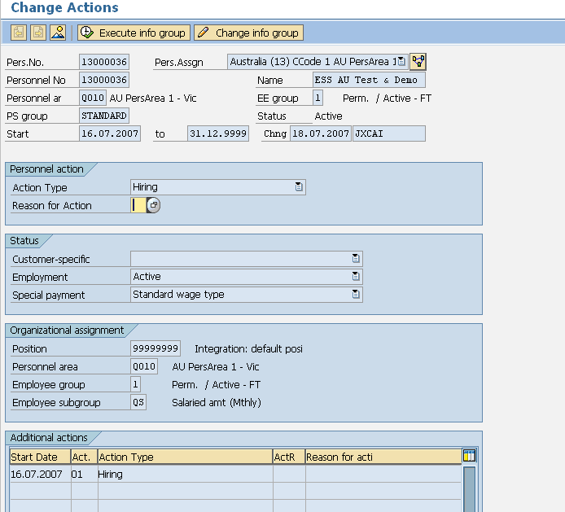

**Description:** All employees must hold an action infotype. It indicates if they are active or terminated and a new record is created when the action type (e.g. hire, transfer, termination) changes.

Key data –

* Employment Status
* Personnel Area
* Employee group
* Employee subgroup information

## Infotype 0001 – Organisational Assignment

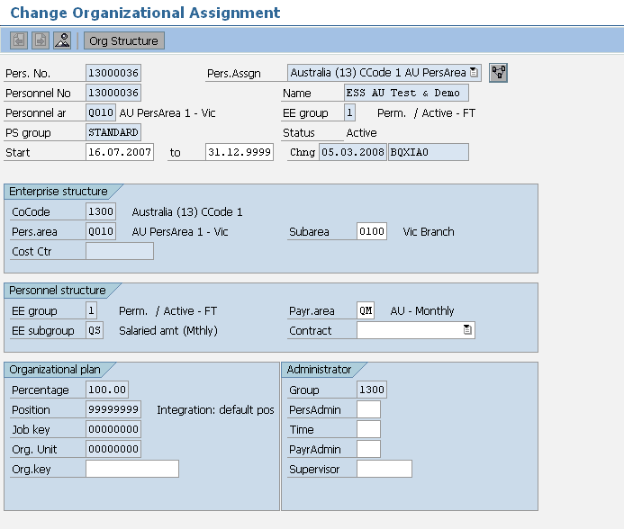

**Description:** This holds all organisational information such as company, location, department etc

Key data –

* Personnel Area – Company Code
* Personnel Sub Area – Location
* Employee Group – Type of worker (e.g. Perm, / Active - FT)
* Employee Subgroup – Employment Band
* Cost centre
* Payroll Area
* Position

## Infotype 0002 – Personal Data

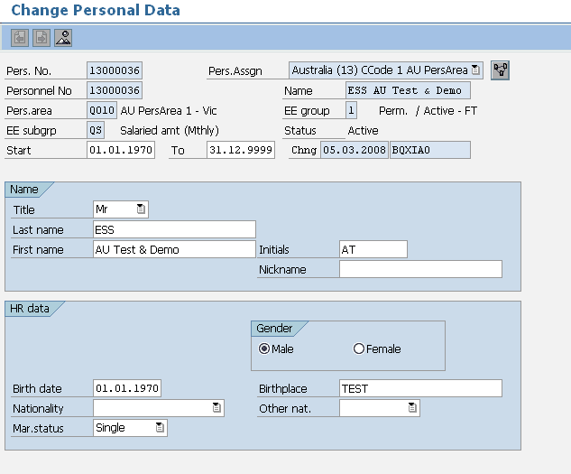

**Description:** This holds personal information relating to the employee.

Key data –

* Form of Address
* Last Name
* First Name
* Gender
* Birth Date

You also have the option of storing additional details if required.

Note that IT0001 and IT0002 can be reloaded separately if necessary. These are not required to be completed for the initial load.

## Infotype 0006 – Addresses

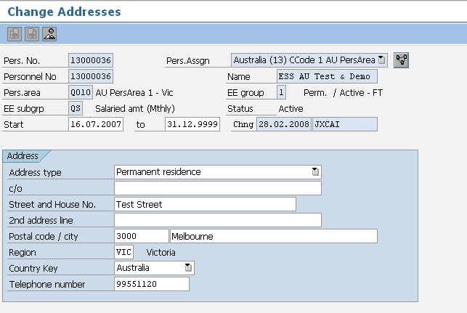

**Description:** Addresses Infotype 0006 data load sheet stores details of employee’s address. Employees may have more than one address type (i.e. Permanent Residence and Postal address). Creating an additional address record for that employee in the data load sheet allows for this.

Key data –

* Address Type (each employee must have Address Type 1 – other subtypes are optional)
* House Number / Street
* Postal Code – Four Digits
* City/District
* State
* Country

## Infotype 0007 – Planned Working Time

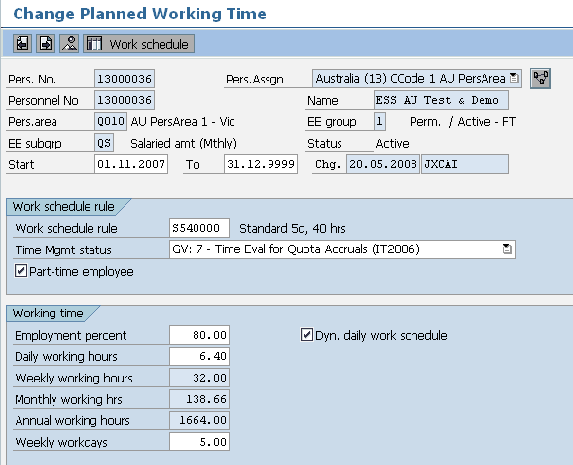

**Description:** Infotype 0007 holds employee work schedule information. The work schedule rule defines the hours worked. There will be a different rule for each country. There may be many more than one work schedule rule available in each country.

Key data –

* Work Schedule Rule
* Employee Time Management
* Part–Time Employee status

## Infotype 0008 – Basic Pay

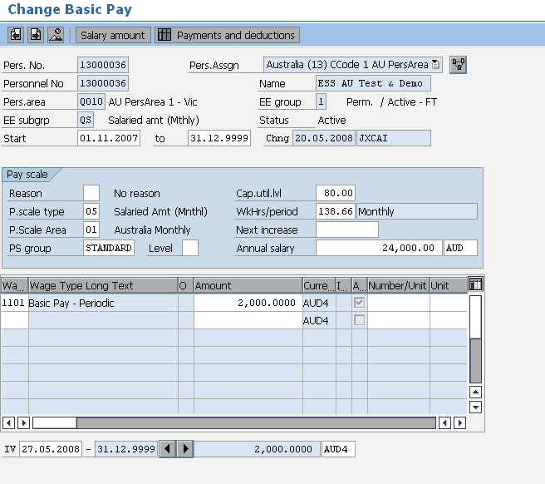

**Description:** This Infotype stores information about an employee’s salary and salary package. Additional Payments and Deductions are a separate Infotype.

Key data –

* The Employee’s Annual Salary
* The Employee’s Monthly Salary
* Additional Salary Package wage types if applicable
* Hourly rates if applicable
* Cap Util Level (employment percent)

## Infotype 0009 – Bank Details

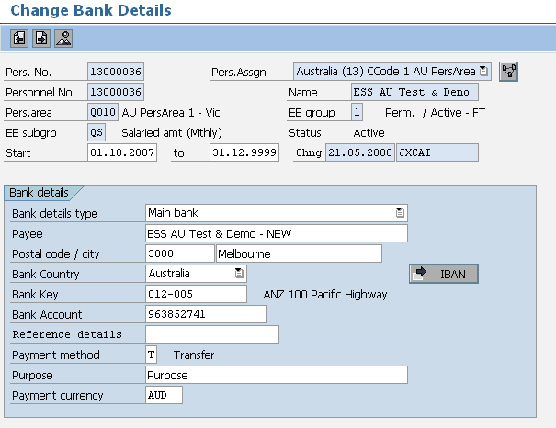

**Description:** This infotype holds details of the employee’s main bank account; an employee may have more than one bank details record. Additional banks hold the same details as the main bank but are entered through either an additional IT0009 record (in which case the money will come out of EVERY pay including off cycles) with a standard value or percentage or through an infotype 0011 record which works exactly like a deduction and will only come out of the main pay not an off cycle. Only employees with Payment method T will appear on the bank file.

Key data –

* Bank Type (0 = Main Bank) (1 = Other Bank)
* Payee
* Postal Code
* City
* Bank Country
* Bank Key
* Account Number
* Payment Method
* Standard Value or Percentage (if “other” bank type)

## Infotype 0011 – External Transfers

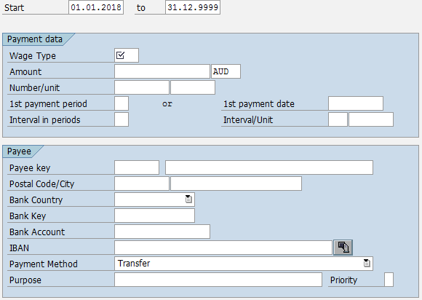

**Description:** External Transfers manages payments to third parties. The infotype defines the deduction to be made during payroll, and the destination to send it to. The design of this infotype is very similar to a combination of IT0014 Payments/Deductions and IT0009 Bank Details. This will be used to pay garnishments.

Key data –

* Wage Type
* Amount
* Payee Key
* Bank Country
* Bank Key
* Bank Account
* Payment Method

## Infotype 0014 – Recurring Allowances and Deductions

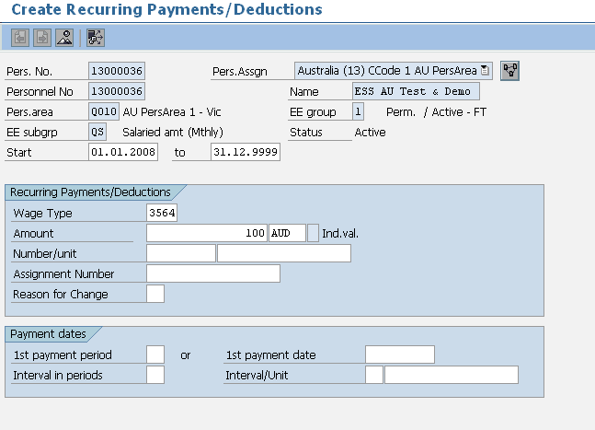

**Description:** Infotype 0014 stores the recurring allowances and deductions that are not included in the salary package; these wage types are permanent and paid monthly.

Key data –

* Wage Type
* Amount
* Number/Unit
* Currency
* Start and End Dates

## Infotype 0015 – Additional Payments

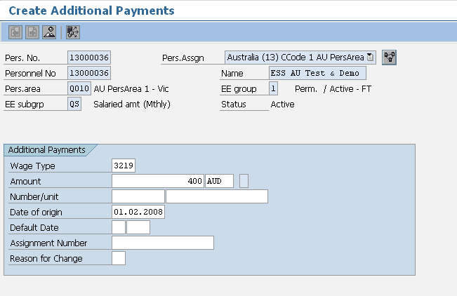

**Description:** Infotype 0015 is used for one off payments; these are known as ad–hoc payments.

Key data –

* Wage Type
* Amount
* Number/Unit
* Currency
* Date of Origin (Start and End Dates in the spreadsheet must be the same)

## Infotype 0016 – Contract Details

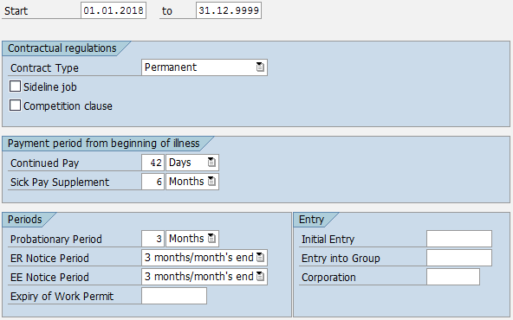

**Description:** Infotype 0016 stores the contract details as well as any applicable probation or notice periods.

This infotype is mandatory for RMIT for the Flexibility Index global strategic report.

Key data –

* Contract Type
* Employer Notice Period
* Employee Notice Period

## Infotype 0027 – Cost Distribution

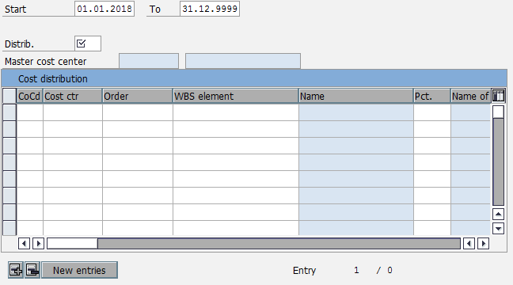

**Description:** This infotype is used to determine how costs for an employee are to be distributed to different account assignment objects. The employee is assigned in Infotype 0001 to a cost center and all her/his payroll cost will be sent to this cost center. This infotype allow assigning a part or all of the costs to another cost center, as an exception to the main cost center maintained in the infotype 0001.

Key data –

* Distribution
* Company Code
* Cost Centre
* Percentage

## Infotype 0041 – Date Specifications

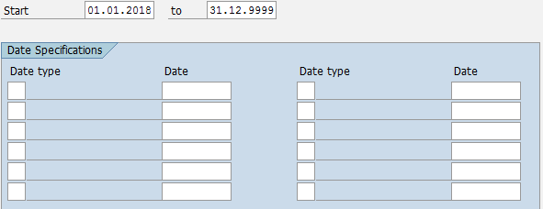

**Description:** Date Specifications holds key dates relating to the employee lifecycle. For example, date of entry to the organisation or date of eligibility to specific benefits.

Key data –

* Date Type
* Date

## Infotype 0045 – Loans

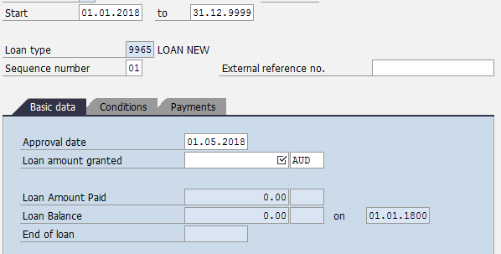

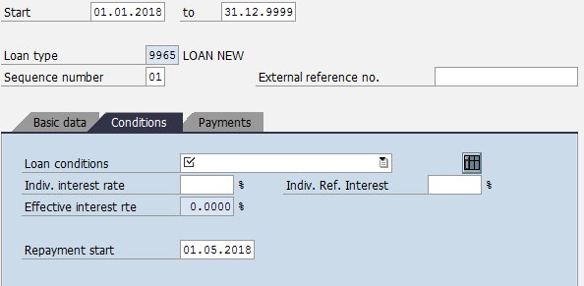

**Description:** Loans is used to hold details of loan arrangements made directly between the employee and the company. This infotype describes the loan conditions and repayment plans and is used by payroll to deduct or pay the entered amounts. The Infotype 0045 loan screen is made up of 3 tabs –

* Basic Data
* Conditions
* Payments (this tab is used to enter Infotype 0078 Loan Payment details)

Key data –

* Loan Type
* Approval Date
* Loan Amount Granted
* Loan Conditions
* Repayment Start Date

## Infotype 0078 – Loan Payments

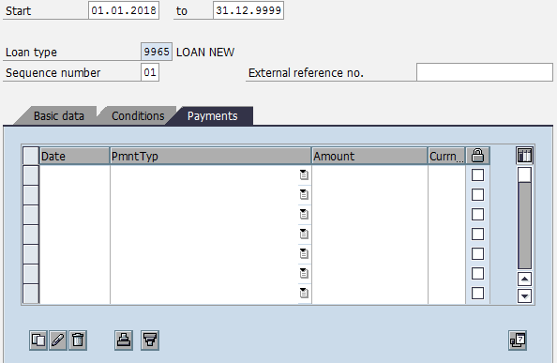

**Description:** Loan Payments should not be accessed directly, but instead is populated when data is entered in the Payments tab of IT0045.

Key data –

* Date
* Payment Type
* Amount
* Currency

## Infotype 0105 – Communications

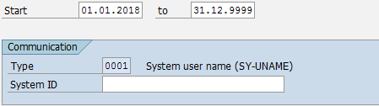

**Description:** This infotype is mandatory for ESS and MSS functionalities. It can be used to store multiple communication details for employees (eg. system user ID, email address, etc).

Key data –

* Communication Type
* ID

## Infotype 0709 – Global ID

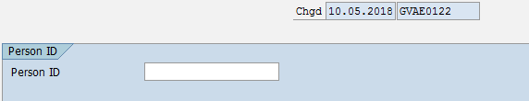

**Description:** Infotype 0709 will be used to store the Global ID of the employee. This is a unique identifier which identifies the employee in GV.

Key data –

* Person ID

## Infotype 2001 – Absences

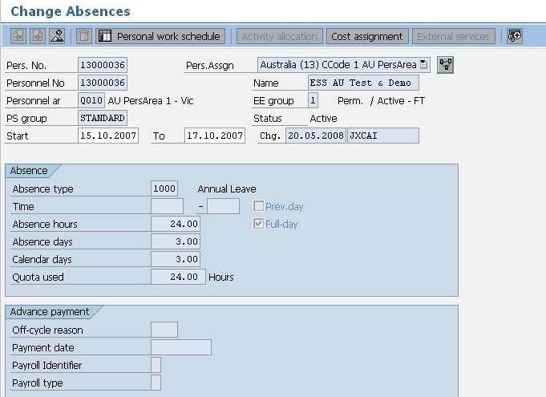

**Description:** This data load sheet loads employee leave entries. However in reality you will rarely need to load leave entries. It is either done by the payroll team or through ESS on an ad hoc basis.

Key data –

* Start and end Dates
* Wage Type
* Start and End Times/Absence Hours (only enter if less than one day’s leave is being applied for)

## Infotype 2003 – Substitutions

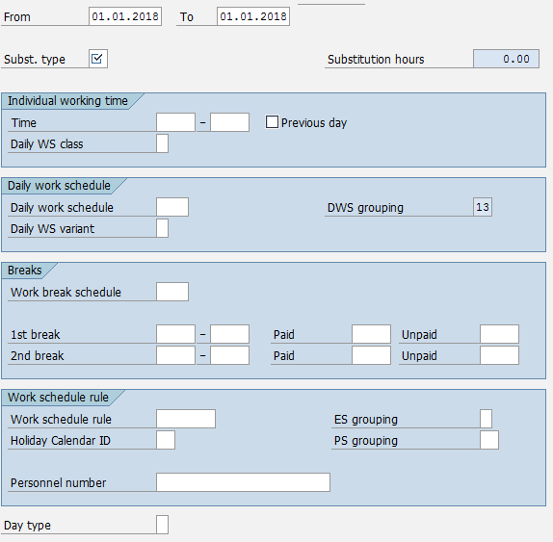

**Description:** Infotype 2003 is used to record deviations in an employee’s planned working time on the Planned Working Times Infotype (0007). Substituting planned working time based on daily work schedule, work schedule rule and/or periods of time in a day is permitted.

Key data –

* Substitution Type
* Time – Start and End Times
* Day Type

## Infotype 2006 – Absence Quotas

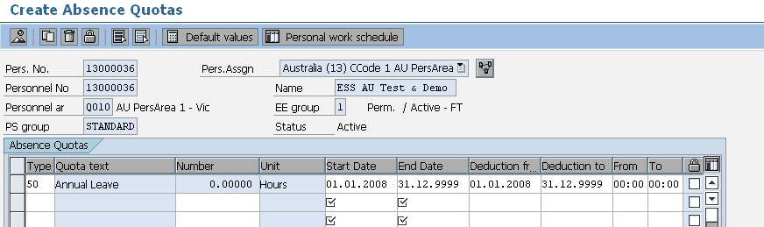

**Description:** In SAP leave is recorded as an absence. Some absences are linked to leave quotas that hold the entitlement and pro–rata values. These leave types are annual leave, sick leave and long service leave etc. When employees are hired a record is created for annual leave, sick leave and long service leave but no quotas are loaded at this point, they are left blank.

Key data –

* Start and End/To Dates
* Leave Type (e.g. Annual = 50, Sick/Personal Leave = 60, Long Service Leave = 70)

## Infotype 2010 – Employee Remuneration Information

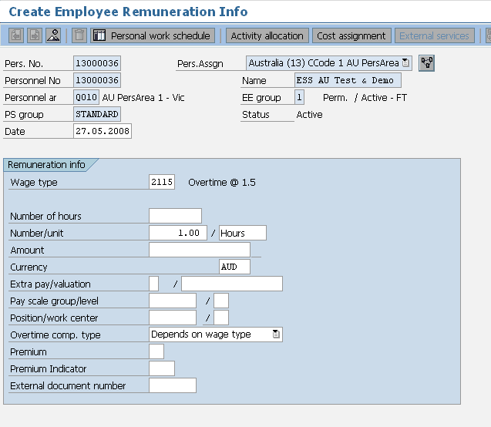

**Description:** This is used to input time sheet entries such as overtime and meal allowances. However this is sometimes done via ESS or manually by the payroll team.

Key data –

* Start and End Dates
* Wage Type
* Amount/Hours
* Note that in the spreadsheet there is a field for Cost centre so that a payment can be assigned to a different cost centre. To do this manually you would click on the cost assignment button.

## Infotype 2012 – Time Transfer Specifications

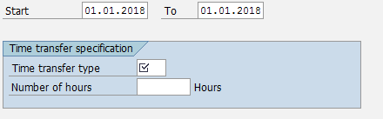

**Description:** Infotype 2012 is used to store time information which is read and used in time evaluation for various purposes.

Key data –

* Time Transfer Type
* Number

## Infotype 2013 – Quota Corrections

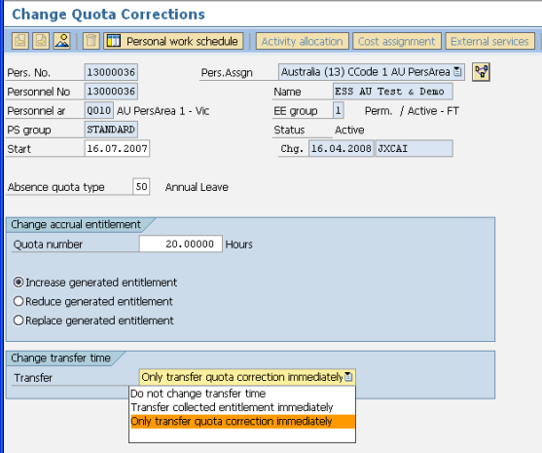

**Description:** Infotype 2013 allows you to increase, reduce or replace leave balances for the appropriate leave type. Therefore when you have loaded an IT2006 for each employee for each leave type that they are entitled to you can use this infotype to load the existing balances into IT2006.

Key data –

* From and To Dates must be the same
* Quota Type
* Quota Number
* Increasing, Reducing, or Replacing Leave Balance
* Transfer Time

# Infotype Overview – Country Specific (AU)

## Infotype 0188 – Tax Australia

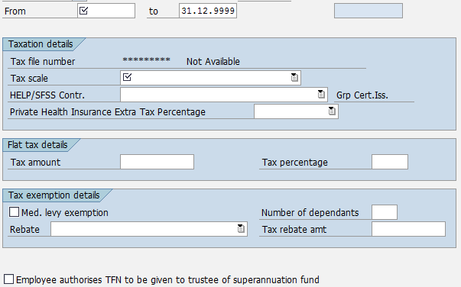

**Description:** Infotype 0188 stores Australia Tax Information including Tax Scale information.

Key data –

* Tax Scale
* HECS/SFSS Contribution Category
* Details of any Flat Tax Amounts
* Tax exemption details and rebates
* Medicare Exempt
* Dependant Information
* TFN to Super Fund flag

## Infotype 0220 – Superannuation Australia

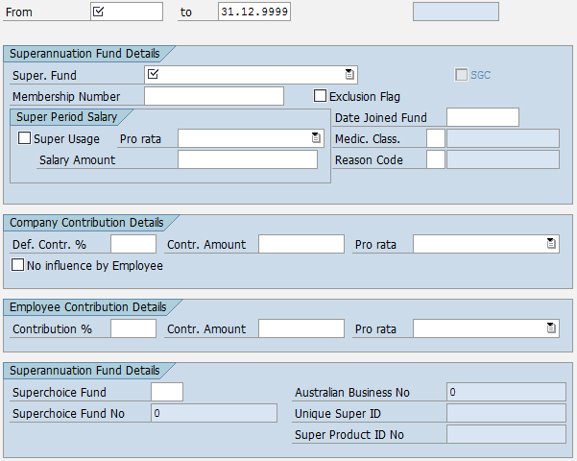

**Description:** Superannuation Australia details are loaded through Infotype 0220.

Key data –

* Superannuation Fund Type
* Super Fund Member Number
* Date Joined
* Salary details if the salary used for super calculation is different to the basic salary
* Details of medical classification (if the employee has had to undergo an examination to join the fund) along with the reason code.
* Contribution details are displayed here but maintained within the system
* Superchoice Fund code
* Australian Business No
* Super Fund No
* Super Product ID No

## Infotype 0227 – Tax File Number

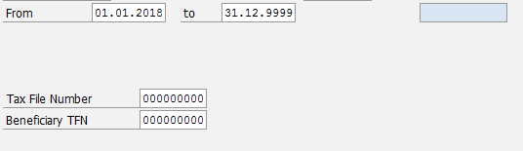

**Description:** Infotype 0227 enables employee’s Tax File Numbers to be loaded.

Key data –

* Start and End Dates (End Date should be 31.12.9999)
* Tax File Number (Should be 9 digit number)

## Infotype 0817 – Withholding Tax Variation

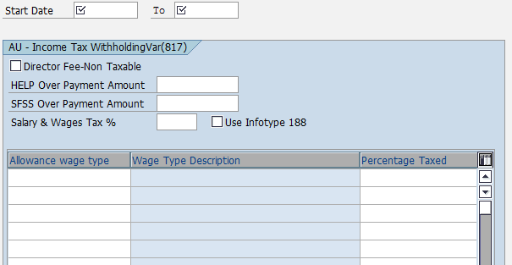

**Description:** The Tax Australia record (IT0188) is the master record for determining an employee’s tax deduction. The details stored in this record are the standard tax scales and rebate keys that are applicable for all employees Australia wide.

There are circumstances however, where an individual has received a ruling from the tax office for their personal circumstances, or where an organisation has received a ruling about a specific payment that can have a different tax treatment. In this case an additional tax record, Income Tax Withholding Variation (IT0817) may be needed.

The tax ruling may only apply to a specific payment the employee receives and not the taxable gross. The details stored in IT0188 apply to the taxable gross. The details in IT0817 can apply to a specific payment only. An example is where an employee has received a variation on their salary and wages, bonuses however are to be taxed as per the standard tax scale. In this case an ITWV record is required to enter details for the salary and wages tax percentage. The tax on bonuses is determined by the tax scale in IT0188. The payroll will use the details stored in both records (IT0188 & IT0817) to deduct the correct amount from the taxable gross components in the payroll.

This record would exist only where an employee has received a tax ruling from the ATO. Without official documentation from the ATO a record should not be created.

Key data –

* Director Fee Non Taxable
* HELP Overpayment Amount
* SFSS Overpayment Amount
* Salary and Wages Tax Percentage
* Use Infotype 0188 flag
* Wage Type
* Percentage Taxed

# Appendix

### ADP Reference Documents

| **ADP GV Document ID** | **Description** | **Document** |
| --- | --- | --- |
| GV00002671 | G2 SSL Data Entry |  |
| GV00009265 | Data Load with the ADP SSL Interface |  |
| [A-PMS0008](https://portal221.globalview.adp.com/irj/servlet/prt/portal/prtroot/com.sap.km.cm.navigation/room_extensions/cm_stores/ADP_Project_Documents/workspaces/e022f269-0f29-3610-d894-aa1cc65e30ca/C.%20Interfaces/Functional%20Specs?StartUri=/room_extensions/cm_stores/ADP_Project_Documents/workspaces/e022f269-0f29-3610-d894-aa1cc65e30ca) | RMIT AU G2 Specification | [Project cRoom](https://portal221.globalview.adp.com/irj/portal?NavigationTarget=CollaborationConnector://portal_content/com.sap.ip.collaboration/Rooms/0097866c-6880-3710-8ea2-f285dc4b04cd/workset) |
| GV00006546 | RMIT AU Blueprint Configuration Worksheet | [Project cRoom](https://portal221.globalview.adp.com/irj/portal?NavigationTarget=CollaborationConnector://portal_content/com.sap.ip.collaboration/Rooms/0097866c-6880-3710-8ea2-f285dc4b04cd/workset) |
| GV00006552 | RMIT AU ADP GV - Payroll Business Blueprint | [Project cRoom](https://portal221.globalview.adp.com/irj/portal?NavigationTarget=CollaborationConnector://portal_content/com.sap.ip.collaboration/Rooms/0097866c-6880-3710-8ea2-f285dc4b04cd/workset) |
|  | RMIT AU ADP GV - Time Business Blueprint | [Project cRoom](https://portal221.globalview.adp.com/irj/portal?NavigationTarget=CollaborationConnector://portal_content/com.sap.ip.collaboration/Rooms/0097866c-6880-3710-8ea2-f285dc4b04cd/workset) |
| [GV00003434](https://portal221.globalview.adp.com/irj/servlet/prt/portal/prtroot/com.sap.km.cm.navigation/room_extensions/cm_stores/ADP_Global_Project_Documents/workspaces/20c39902-a9a6-3510-10b1-a2ce70767711/2-Global%20Design%20(GTD%2cxSS%2cGTD)/GTD/GTD%20Final%20versions?StartUri=/room_extensions/cm_stores/ADP_Global_Project_Documents/workspaces/20c39902-a9a6-3510-10b1-a2ce70767711) | RMIT Global Template Document | [Project cRoom](https://portal221.globalview.adp.com/irj/portal?NavigationTarget=CollaborationConnector://portal_content/com.sap.ip.collaboration/Rooms/0097866c-6880-3710-8ea2-f285dc4b04cd/workset) |
| - | SSL Template | [Project cRoom](https://portal221.globalview.adp.com/irj/portal?NavigationTarget=CollaborationConnector://portal_content/com.sap.ip.collaboration/Rooms/0097866c-6880-3710-8ea2-f285dc4b04cd/workset) |
| - | Template – YTD Data Example | [Project cRoom](https://portal221.globalview.adp.com/irj/portal?NavigationTarget=CollaborationConnector://portal_content/com.sap.ip.collaboration/Rooms/0097866c-6880-3710-8ea2-f285dc4b04cd/workset) |